EXPERIMENT 9
CREATE TABLE BANK_21(
bankcode VARCHAR(3) PRIMARY KEY,
bankname VARCHAR(50) NOT NULL,
headoffice VARCHAR(50),
branches INT CHECK (branches > 0));
INSERT INTO Bank_21 VALUES ('101', 'SBI', 'Ernakulam', 120);
INSERT INTO Bank_21 VALUES ('102', 'SIB', 'Kottayam', 80);
INSERT INTO Bank_21 VALUES ('103', 'ICICI', 'Ernakulam', 60);
INSERT INTO Bank_21 VALUES ('104', 'kerala grameen bank', 'Trivandrum', 40);
INSERT INTO Bank_21 VALUES ('105', 'Federal', 'Aluva', 70);
select * from BANK_21;
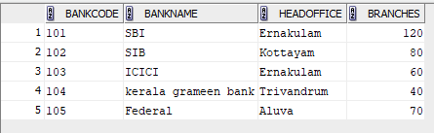
CREATE TABLE BRANCH_20 (
branchid INT PRIMARY KEY,
branchname VARCHAR(50) DEFAULT 'New Delhi',
bankid VARCHAR(3),
FOREIGN KEY (bankid) REFERENCES BANK_21(bankcode));
INSERT INTO Branch_20 VALUES (1, 'Kottayam', '101');
INSERT INTO Branch_20 VALUES (2, 'Ernakulam', '102');
INSERT INTO Branch_20 VALUES (3, 'Kottayam', '103');
INSERT INTO Branch_20 VALUES (4, DEFAULT, '104');
INSERT INTO Branch_20 VALUES (5, 'Kottayam', '105');
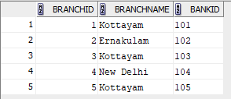
I Create a View named bank_head office to hold the details of
all bank whose head office at Ernakulam.
CREATE VIEW bank_head_office AS
SELECT * FROM Bank_21
WHERE headoffice = 'Ernakulam';
select * from bank_head_office;
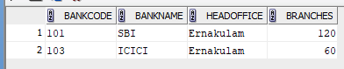
II) Create a View named bank_branch to hold the details of all bank who have branches
at kottayam.
create view bank_branchs AS select B.* from BANK_21 B JOIN BRANCH_20 BR ON B.bankcode
= BR.bankid where BR.branchname = 'Kottayam';
select * from bank_branchs;
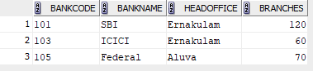
III) Create a View to show banks with more than 50 branches
CREATE VIEW banks_more_than_50 AS
SELECT *
FROM BANK_21
WHERE branches > 50;
select * from banks_more_than_50;
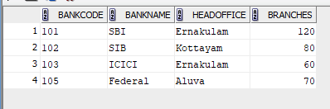
IV) Create a View to display bank name and branch name
CREATE VIEW bank_branch_details AS
SELECT B.bankname, BR.branchname
FROM BANK_21 B
JOIN BRANCH_20 BR ON B.bankcode = BR.bankid;
select * from bank_branch_details;
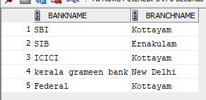
V) Create a View to show banks located outside Ernakulam
CREATE VIEW banks_outside_ernakulam AS
SELECT *
FROM BANK_21
WHERE headoffice <> 'Ernakulam';
SELECT * FROM banks_outside_ernakulam;

